Parth Babbar

9999940289  kishibabbar@gmail.com

Federal reserve system

**Introduction:**

The Federal Reserve System, also known as the Federal Reserve or the Fed, is the central bank of the United States. The Federal Reserve Act, enacted on December 23, 1913, established its primary goal of ensuring the safety, flexibility, and stability of the nation's monetary and financial systems. The Federal Reserve plays a critical role in the United States economy, influencing monetary policy, regulating and supervising banks, preserving financial stability, providing financial services, and protecting consumer interests.  
  
**History & Background & Evolution:**

1. **Established:** December 23,1913  
   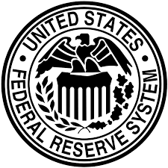
2. **Legislation:** Established under the Federal Reserve Act of 1913. It was developed in reaction to a succession of financial panics, most notably the 1907 panic, to offer a more secure, stable monetary and financial system.
3. **Creation and Early Year:** The Federal Reserve System, sometimes known as the Federal Reserve or Fed, was established in reaction to recurrent financial panics, most notably the Panic of 1907. Initially, its primary goal was to produce a more elastic currency and serve as a lender of last resort.
4. **Great Depression & Reform:** The Great Depression produced major reforms, notably the Banking Act of 1935, which reinforced the Federal Reserve's structure and powers.
5. **Post-World War II:** The Federal Reserve had a critical role in aiding the postwar economic boom, which contributed to long-term economic development and stability. However, it had difficulty during the 1970s, notably in regulating inflation amidst economic swings and shifting global dynamics.
6. **Modern Era:** In response to the 2007-2008 financial crisis, the Federal Reserve emphasised financial stability and used unorthodox measures such as quantitative easing. Similarly, during the COVID-19 epidemic, it expanded its role in ensuring economic stability by implementing extraordinary efforts to boost the economy and assure liquidity.

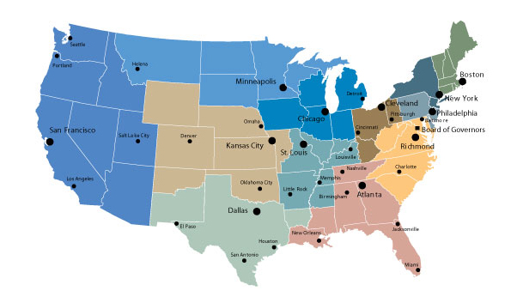  
The above map consists of the districts in Federal Reserve System.

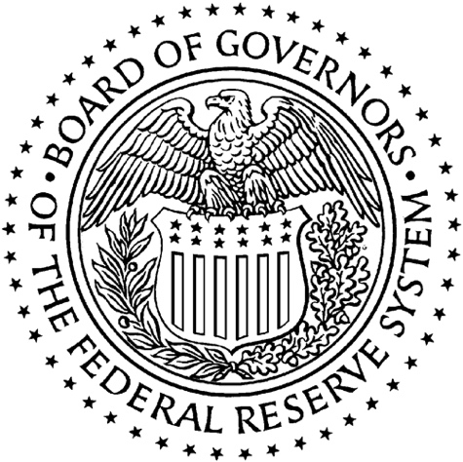

The above is the Seal of the Board of Governors of the Federal Reserve System.

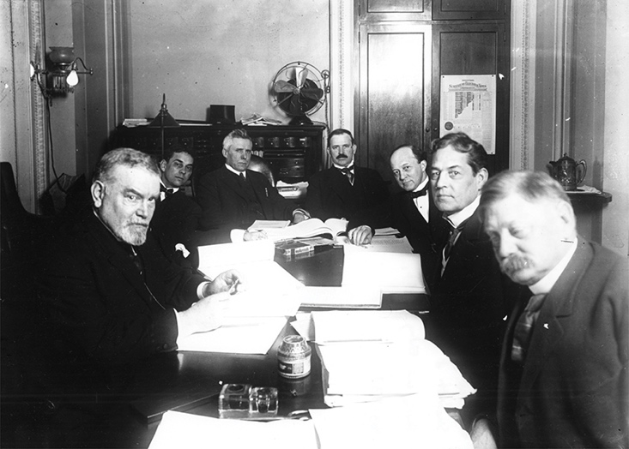

This is an image of the Senate Banking Board of trustees in meeting during the discussion about the Central bank Demonstration of 1913. At that point, Robert L. Owen, envisioned on the right, was top of the board.

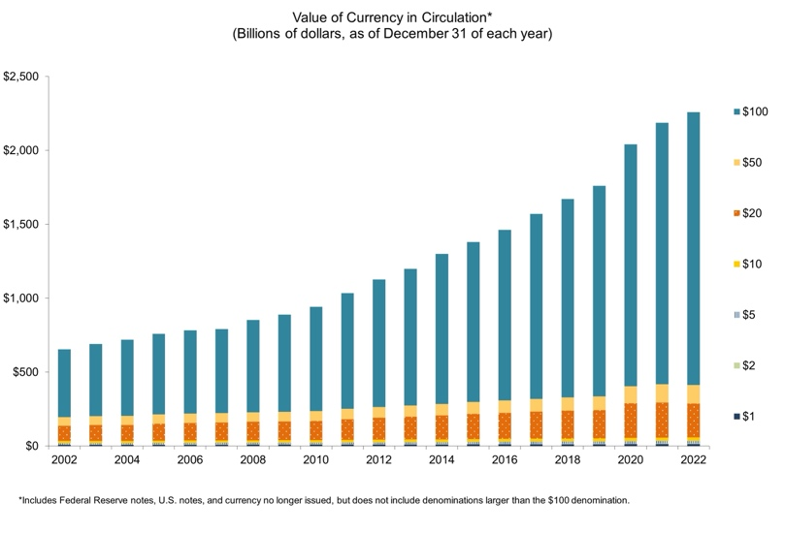  
This is about the Federal Reserve Banks.

**Functions:**

1. **Monetary Policy:** The Federal Reserve uses national monetary policy to impact money and credit conditions, with the goal of achieving full employment, stable prices, and moderate long-term interest rates. To achieve these goals, it uses a variety of tools, including open market operations, the discount rate, and reserve requirements. In addition, the Fed uses interest on excess reserves as a tool for successful monetary policy management.
2. **Supervising & Regulating:** The Federal Reserve supervises and regulates a variety of organisations, including bank holding companies and state-chartered member banks, to maintain the safety and soundness of the country's banking and financial system. It regulates banks by conducting on-site exams and off-site surveillance to ensure both their stability and consumers' credit rights.
3. **Financial Services & Stability:** The Federal Reserve monitors and analyses financial system risks while acting as a lender of last resort during crises. Its clientele include the United States government, commercial banks, and foreign government agencies. The Federal Reserve supervises payment systems such as cheque clearing and electronic payments, as well as the distribution of cash and coins. It also provides financial services such as electronic money transfers and currency issuance to depository institutions and international governmental entities.
4. **Customer Protection:** The Federal Reserve enforces a variety of consumer protection rules and regulations, as well as encouraging community development and equitable credit access.

**Key Program:**

1. **Open Market Operation:** Open market operations involve the purchase and sale of government securities on the open market. This is the Federal Reserve's key weapon for influencing the quantity of money and credit in the economy and successfully implementing monetary policy.
2. **Discount Rate:** The discount rate is the interest rate placed by the Federal Reserve Banks on short-term loans to commercial banks and other depository institutions. It is used to control the supply of money and credit in the economy.
3. **Reserved Requirements:** Reserve requirements are regulations that specify the minimum amount of reserves that banks must retain against deposits. They guarantee that banks have enough liquidity to accommodate client withdrawals while also controlling the money supply and implementing monetary policy.

**Conclusion:**

The Federal Reserve System is an essential component of the US economy, with its extensive structure and numerous functions meant to ensure a stable and efficient financial system. The Fed's monetary policy, regulatory functions, and financial services all strive to promote economic well-being and financial stability.